Instructional Design Lesson #1
Organization Procedure: Cleaning Up
Teacher: Jubilee Rivera-Hernandez
Grade Level: 2nd grade (15 students)
Time: 15 minutes
Description of school and classroom context:
My ideal school would be situated in an urban or suburban Denver community full of diverse K-5 learners and teachers. Students have diverse home languages, though most students speak English and/or Spanish at home. Furthermore, students are culturally, racially, and ethnically diverse. In addition, students have various modality preferences (e.g. audio, visual, kinesthetic) and academic inclinations (e.g. passion for science, the arts, math, etc.). As such, while students have various teachers who teach specific subjects, the teachers work together to find balanced ways of integrating the subjects to better support students’ holistic learning while engaging students in their preferences. Students have teachers specialized in the arts, physical education, and languages and a designated homeroom teacher who teaches reading, writing, math, science and social studies. As a second-grade homeroom teacher in this diverse school context, I strive to provide instruction that engages my students’ diverse backgrounds, prior knowledge and experiences, and learning preferences and interests.
Classroom Procedure Objective: Students will be able to clean up after every lesson or activity.
Language Objectives:
- Speaking: Students will be able to ask Mrs. Rivera, classmates, and/or family for help. Students will be able to offer help to their classmates.
- Listening: Students will be able to listen to and follow Mrs. Rivera’s instructions.

Key Vocabulary:
- Cleaning (n): The action of making something clean, especially the inside of a home.
- Tidy (v): Arrange something neatly.
Materials:
- Poster of clean up routine (Appendix A)
- Poster paper or screen share of drawing white board (Appendix B)
- Poster of sample questions to ask or offer help (Appendix C)
- Photos of examples and non-examples for remote version (Appendix D)
- Markers or Keyboard
- Classroom materials (e.g. books, math manipulatives, pencils, etc.) for in-person version and binders and papers for the remote version.
- Clean-up songs (Appendix E)

IN PERSON VERSION
- TEACH PHASE (9 minutes)
  - Introduce clean up procedure: “Class, we spent some time learning where our math, science, reading, writing, and social studies materials live in our classroom. I think it is important that we now learn how to return our materials to their homes after each learning activity and keep our classroom clean and tidy. Cleaning means to make something clean and often includes making things tidy. Tidy means to arrange something neatly. Why do you think it is important that we keep our spaces clean and tidy?
  - Allow time for students to share why they think cleaning up is important. (I will write their ideas on the poster paper.) “Thank you for sharing your ideas. Based on what you all shared, there are many reasons why clean-up is so important, like cleaning up to honor our spaces and show others we care for them. What are some ways that we clean up? Think back to kindergarten and first grade, what did you and your classmates do to keep the classroom clean and tidy? How do you clean at home or in other afterschool settings?
  - Allow time for students to share what clean-up has looked like for them in the past. (I will write their experiences on the poster paper.) “Some common things that I am noticing us say is we clean our spaces by putting things back where they belong and throwing trash away. So, let’s learn how clean-up will look like in our classroom.”
  - Explanation and modeling of the procedure: (As I go through each step, I will point to the step on the poster I have made for our clean-up routine. The poster will have accompanying visuals, and a Spanish version of each step. In addition, I will model walking to put materials away, how to place a material back in its home, and walking to the rug as I go through each step. The use of a visual timer is beneficial as well).
    - Step 1: “When it is time to transition or move on to our next learning activity, I will give you 3 warnings (indicate with 3 fingers) before you need to start cleaning up your area. When you have 5 minutes before you need to clean up, I will say, “You have 5 minutes until we clean up our materials!” (indicate with 5 fingers). While you do not need to start cleaning up, I do want you to mentally prepare and start to think ‘okay, I have 5 more minutes to work on this’. When you have 3 minutes left, I will say, “You have 3 minutes until we clean up our materials!” (indicate with 3 fingers). Now you should be thinking ‘I have 3 minutes before I need to clean up, so a little more time to work on this.’ Finally, I will say, “You have 1 minute until we clean up our materials!” (indicate with 1 finger). Now you should think to yourself, ‘I need to finish what I am currently doing’ and this can mean finishing the sentence in the book you are reading, or finish coloring the section of your drawing that you are working on. Those are just examples.”
    - Step 2: “After that 1 minute that you have left before we need to clean up, I will play a song that will be our designated cleaning up song. So, as soon as you hear the song start to play, you need to stop what you are doing, hold up your hands so you aren’t touching the materials (hold up my hands), and then begin returning the materials to their home. This means that you will grab each material you used, walk to its home, and place the material down calmly and exactly how you found the item when you first grabbed it. Once your area is clean, I encourage you to help a classmate finish cleaning their area. In this class we work together! So, I appreciate if you help a classmate so we can all be successful in cleaning up, and I am sure your classmate may appreciate the help as well, especially if they have a lot of materials they need to put back.” (I will grab a material in front of me and walk it to its home as a model).
      - (In the future, whenever we do the clean-up routine, as students are cleaning up, I will walk around and offer specific praise such as “Yesenia, I really like the way you tidied up the bookshelf” and “Darian, thank you for putting the blocks away in their home container”. I will also walk around so that I am available if any student has a question such as where an item needs to go.)
    - Step 3: “Once you are done cleaning up your area by returning the materials to their home, and once you are done helping a classmate clean their area if you have time to help, then please walk over to our rug, and sit patiently until all your classmates and myself join the rug. You are welcome to sit on the rug before the song ends, but only after you have cleaned up your area.” (model walking over to the rug and sit criss crossed, but don’t force students to sit this way if they physically can’t or prefer not to because of cultural reasons. Instead emphasize, ‘keeping my body parts to myself in a way that helps me focus’).
    - Step 4: “Once every student is sitting on the rug, I will come and join you. I will then thank you for cleaning up, give reminders about our clean up routine, and explain our next learning activity.”
    - Reminders: “Some things to remember, always walk to put the materials away and to the rug. We want to be safe and avoid anyone getting hurt. I have no problem with you talking or asking questions while we clean up. I encourage you to ask me or your classmates questions if you forget where an item goes by asking, “Hi, __ may you help me find its home?”. I also encourage you to offer to help another classmate by asking, “Hi ___ may I help you clean up?” or “Would you like me to help you?” Just remember to use your inside voice so everyone can hear the song. Can someone share what an inside voice means?... Yes, an inside voice means we do not yell, we only talk loud enough so that the person next to us can hear us.”
  - Time for questions and clarification: “Before we try this out as a class, do any of you have any questions?” “Is there anything you would like me to go over again?” “Remember, if you have any questions please ask me. I know we recently learned where our materials live so it is okay if you forgot where the materials go. I am here to help you.”
- REHEARSE PHASE (5 minutes)
  - Students will clean up on their own and offer help to those at their table: “Since this is just a practice, I will say the 3 warnings, one right after the other, but I will not wait the full 5 minutes. I will then play the song. I have placed random items at each table. Once the song starts, you will each grab two items and return them to their home. There will still be items on the table, so as a group, at your table, return those materials. Please work together to figure out where the materials belong. Practice asking each other, “would you like me to help you with this material?” “May you help me put this item away?” and “do you know where this material goes?”. If no one in your group remembers where the item goes please ask me. These questions are here on display so you can see them and practice asking. Once your table returns all the materials to their homes, as a table, please walk and sit on the carpet. This is not a race to see which table moves faster, I just want everyone to be successful in learning our clean-up routine. I will stop the song after 2 minutes”
    - (Remember to walk around as the students clean up, pay attention to what students are doing well and what they need to work on, share my observations with the students at the rug. While we are at the rug ask students to share what the experience was like, and if they have any questions or confusions about the routine. Share with them that once we have our cleaning routine down, as a class we will vote for a new clean-up song.)

- REINFORCE PHASE (1 minute)
  - (As mentioned above, at the rug I will go over what students did well, what we need to improve on, and give reminders of the process.)
  - “Don’t worry if you still need some practice getting this routine down! We will go through this routine every day, and as time goes on, I am sure we will be experts in cleaning and tidying our class materials and classroom!”
  - (To continue to reinforce, we will move on to our next learning activity, where at the end I will enact the full clean-up routine, so students can try the clean-up routine in a very authentic way. As this is a daily routine that we need to do multiple times a day, students will have ample opportunity to practice this routine.)

REMOTE VERSION
- TEACH PHASE (9 minutes)
  - Introduce clean up procedure: “Class, we spent some time learning where our math, science, reading, writing and social studies materials live on our classroom website. I think it is important that we now learn how to keep our physical learning spaces clean and tidy, even from our own homes. Cleaning means to make something clean and often includes making things tidy. Tidy means to arrange something neatly. Why do you think it is important that we keep our spaces clean and tidy?
  - Allow time for students to share why they think cleaning up is important. (I will write their ideas on the zoom white board.) “Thank you for sharing your ideas. Based on what you all shared, there are many reasons why clean-up is so important, like cleaning up to honor our spaces and show others we care for them. What are some ways that we clean up? Think back to kindergarten and first grade, what did you and your classmates do to keep your desks clean and tidy? How do you clean at home or in other afterschool settings?
  - Allow time for students to share what clean-up has looked like for them in the past. (I will write their experiences on the zoom white board.) “Some common things that I am noticing us say is we clean our spaces by putting things back where they belong and throwing trash away. So, let’s learn how clean-up will look like in our classroom but in your home.”
  - Explanation and modeling of the procedure:
    - Below I talk about using two separate binders. Alternatively, if this is too much for 2nd graders to manipulate, it is better to have the daily binder and subject specific folders to file old work in.
    - “Our classroom will follow the same schedule every day. We may have different papers like worksheets that we will use for each subject, so it is important that we keep our papers clean and tidy and all in one place for easy access. To help you stay organized, that is, clean and tidy, I encourage you to follow the process I am about to share with you. This is what we will do together, daily before the end of the school day. I have asked your families to join us in this lesson so they can support you if you need any help.”
    - Step 1: “In a 1-inch binder, I want you to keep all the materials you will need, to participate in every learning activity for that day. This is what your binder should look like, on the outside it has a list of our schedule and is called “the daily binder”, and on the inside, your binder should only have the dividers. Each divider has a tab labeled reading, writing, math, science, or social studies.” (I will show what my binder looks like on the outside and inside, the dividers being the dividers that come with tabs. I will put my binder up close to the camera).
    - Step 2: “I am now going to add in the papers that I need for each lesson. The order of papers will mirror our schedule. So, since reading is first, I will put my papers for reading after the reading divider. Second, I will put my writing papers after the writing divider. Third, I will put my math papers after the math divider. Fourth, I will put my science papers after the science divider. Last, I will put my social studies papers after the social studies divider.” (I am modeling this as I talk).
    - Step 3: “I am going to close my binder and keep it right here next to my computer. I am now ready for tomorrow! This is what we will need to do everyday at the end of the school day, so we are prepared for learning the next day. This 1-in binder will be called our daily binder” (Be very clear and obvious about setting my binder down on my desk, next to my computer).
    - Step 4: “Imagine it is the end of the day, we have used all our papers that are in our daily binder. So, to prepare for the next day what do I need to do? I need to empty out these papers and put in the new papers in my daily binder for the next day. You’re probably thinking, ‘but Mrs. Rivera, what do I need to do with the papers I just took out? Do I throw them away?’ Of course not! We now need to keep the filled-out papers in an organized space. So, in a separate 3-in binder, formatted the exact same way as your daily binder, you will take those loose filled out papers and put them behind the subject divider they belong to. The difference between your daily binder and this bigger binder, is the bigger binder is called “the weekly binder”. So, this means that you will add all the completed papers to this weekly binder. On Fridays, I will pick up your weekly binders, and return them on Monday, empty and clean.” (I will model taking my papers out of the daily binder, putting in the new papers in the daily binder, and putting the “old” papers in the “weekly binder”).
  - Time for questions and clarification: “Before we try this out as a class, do any of you have any questions?” “Is there anything you would like me to go over again?”
- REHEARSE PHASE (5 minutes)
  - “First, let us do this as a class to get some practice! Then, I will ask one of you brave students to volunteer and show us how to organize our binders! So, pay careful attention as we walk through this together.” (I will repeat the steps and will now watch to see how the students are doing).
  - (At the end I will then ask) “Now that you tried that out for the first time, what was that like for you? Give me a thumbs up for ‘it was great, I have it down’ a sideways thumbs up for, ‘it was great, but I need more practice’, and a thumbs down for, ‘I need more practice and have some questions’.”
  - “Would someone who gave a thumbs up like to walk us through the routine, so we see it one more time in action?”
  - “Does anyone have a question they would like to ask about the routine?”
- REINFORCE PHASE (1 minute)
  - “Now that our daily binder is full of the papers we need for the next day, we are prepared for tomorrow! Don’t worry if you still need some practice getting this routine down! We will go through this routine every day, and as time goes on, I am sure we will be experts in cleaning and tidying our class materials and classrooms at home! Remember, if you need support please feel free to ask me questions, and when I am not available or around, ask your family questions, they are a great resource too!”
  - “As a reminder of what a clean and tidy binder looks like here is an example and a non-example” (I will have a slide with the photo of an organized binder and a disorganized binder).
  - “Tomorrow we will learn how to keep our electronic materials clean and tidy, just as we learned how to keep our paper materials organized.”

APPENDICES
APPENDIX A
Poster of Clean-up Routine in English (In-Person)
Clean-up Routine
Step 1: 3 Warnings
Step 2: Song plays, I clean
Help a friend out!
Step 3: Walk to and sit on rug
Step 4: Listen for next steps

Poster of Clean-up Routine in Spanish (In-Person)
Rutina de Limpieza
Paso 1: 3 Avisos
Paso 2: Se reproduce la canción, limpio
Ayuda a un amigo/a!
Paso 3: Camina hasta la alfombra y siéntate en ella
Paso 4: Escuche los próximos pasos

APPENDIX B
Chart for Cleaning Discussion (In-person and Virtual)
Why is cleaning important? | What are ways we keep our spaces clean and tidy?

APPENDIX C
Poster of Sample Questions (In-Person)
How to Ask for Help | How to Offer Help
- Hi __ may you help me find its home?  - May you help me put this item away?  - Do you know where this material goes? | - Hi ___ may I help you clean up?  - Would you like me to help you with this material?  - Would you like me to help you?

APPENDIX D
Example and Non-example of Binder Organization (Virtual)
Example: Clean and Tidy! | Non-example: Messy and Dirty
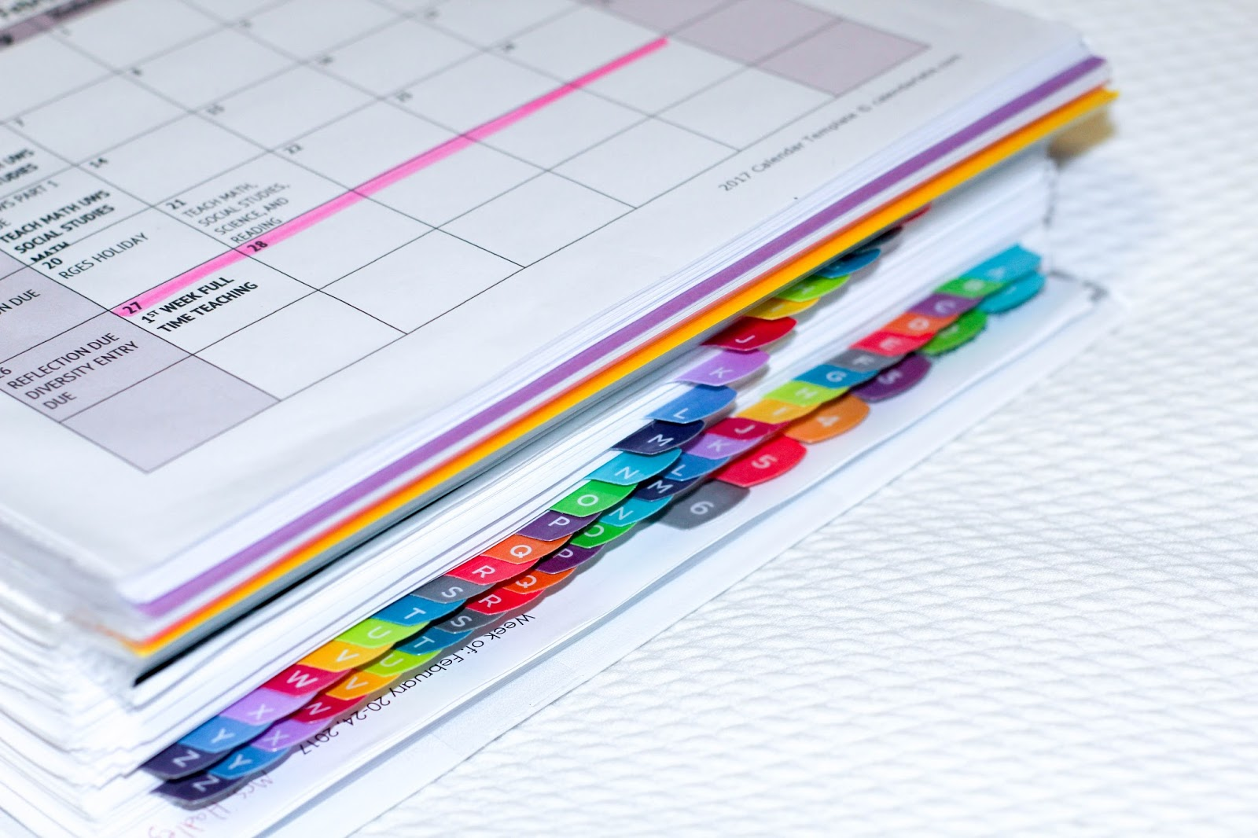 | 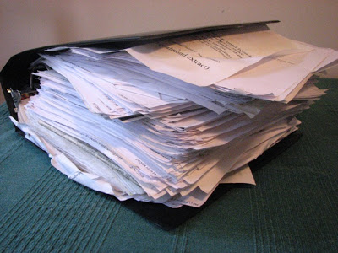

APPENDIX E
Clean-up Song Options (In-Person)

Once students have mastered the cleaning procedure, I would like to give them the option to choose songs they may listen to at home when they clean or would just enjoy listening to as they clean. For now here are two songs specifically about cleaning:

- https://www.youtube.com/watch?v=oY-H2WGThc8 (2 min.)
- https://www.youtube.com/watch?v=gPq7wzGEjqE (3 min.)

